**Kubernetes Task**

Set up minikube at your local and explore creating namespaces (Go through official documentation).

**Start Minikube**

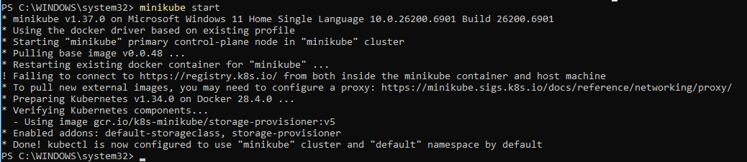

**Verify Installation**

